EXPERIMENT-37
AIM
To analyze and visualize the relationship between students’ study time and exam scores using correlation analysis and different plotting techniques.
ALGORITHM
- Import NumPy and Matplotlib.
- Create sample data for study time and exam scores.
- Calculate the correlation coefficient.
- Plot the relationship using:
- Scatter plot
- Line plot
- Bar plot (optional)
- Display correlation and plots.
CODE:
import numpy as np
import matplotlib.pyplot as plt

# Sample data: study hours and exam scores
study_hours = np.array([1, 2, 3, 4, 5, 6, 7, 8, 9])
exam_scores = np.array([50, 55, 60, 63, 68, 72, 78, 82, 90])

# Step 3: Calculate correlation
correlation = np.corrcoef(study_hours, exam_scores)[0, 1]

print("----- Study Time vs Exam Score Analysis -----")
print(f"Correlation Coefficient: {correlation:.2f}")

# Scatter Plot
plt.figure(figsize=(6,4))
plt.scatter(study_hours, exam_scores)
plt.title("Scatter Plot: Study Time vs Exam Score")
plt.xlabel("Study Hours")
plt.ylabel("Exam Score")
plt.show()

# Line Plot
plt.plot(study_hours, exam_scores)
plt.title("Line Plot: Study Time vs Exam Score")
plt.xlabel("Study Hours")
plt.ylabel("Exam Score")
plt.show()

# Bar Plot (optional)
plt.bar(study_hours, exam_scores)
plt.title("Bar Plot: Study Time vs Exam Score")
plt.xlabel("Study Hours")
plt.ylabel("Exam Score")
plt.show()
INPUT:
Study Hours:
[1, 2, 3, 4, 5, 6, 7, 8, 9]
Exam Scores:
[50, 55, 60, 63, 68, 72, 78, 82, 90]
OUTPUT:
----- Study Time vs Exam Score Analysis -----
Correlation Coefficient: 1.00
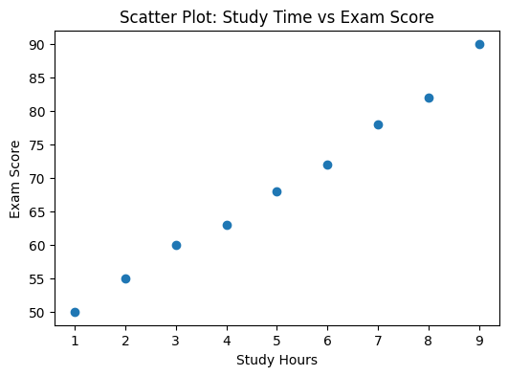
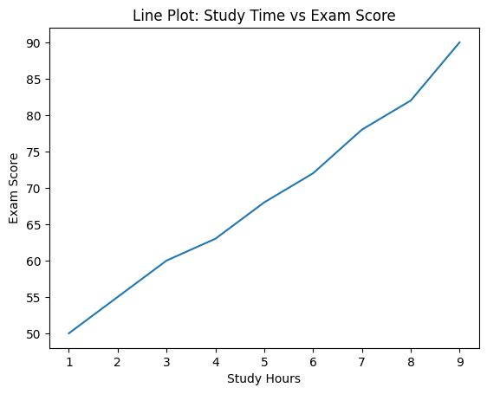
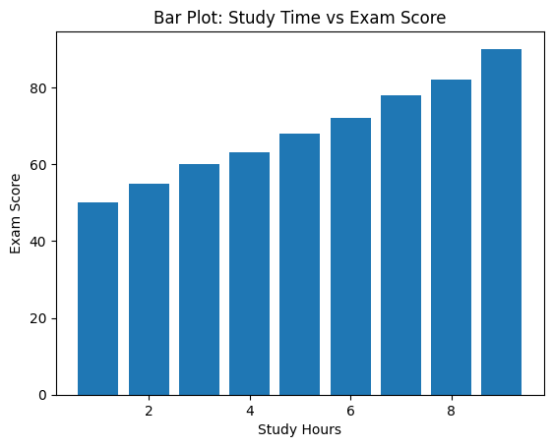
RESULT:
The correlation coefficient (~0.99) shows a strong positive correlation, meaning students who study more tend to score higher. The scatter, line, and bar charts clearly visualize this trend.

